Due date: September Week of September 7to 14, at the end of lab period

Mark: 10

## Purpose:

The Purpose of this lab is to ensure the operation of essential college systems and the installation of critical software on your laptop.

## Objectives:

1. Connect to the ACSecure Network Wirelessly
2. Connect to the printer in room T-111 and print a test page
3. Install any Operating System Essential Updates
4. Install an Anti-Virus product if you already don’t have one installed and ensure it is updated.

## Required equipment and supplies:

* Laptop running Microsoft Windows 8.x
* Algonquin College Network User Id and Password
* Network Connection to the World Wide Web

## Procedure:

## Connecting to the Wireless Network

Once you have a network account, you can connect to the College networks including the wireless networks. Wireless networking is provided throughout the Woodroffe campus. To connect to a campus wireless network, you require:

1. Your network account username and password
2. A wireless laptop with updated wireless drivers
3. A connection profile set up on the device
4. A strong wireless signal

The wireless network on Campus that we will be using for your course is: ACSecure **-** the main student wireless network.

To connect to the wireless network:

1. Click on the wireless icon on your lower desktop or upper right icon



1. Select ‘ACSecure‘, then ‘Connect’
2. Once you’re connected, you will be prompted to enter your Algonquin network username and password
3. Accept the certificate when you are prompted
4. Once you sign in with your network ID, the device will be configured to connect to **‘ACSecure’**. This should only take a minute or two.

## Printing in T111 using the printer’s built-in print server

1. Under Windows 8, press the Windows key and press the ‘X’ key. This brings up the power users menu, choose “Control Panel”.
2. Select “**View devices and printers**”under“**Hardware and Sound**” (Category view).
   1. Click **“Add a printer”**(top left)
   2. If the printer for T-111 does not show up after a minute or two of searching. Click on **‘The printer that I want isn’t listed’**
3. Choose **"Add a printer using a TCP/IP address or Hostname** "Click on the Next button  
   Enter the IP address, **10.50.11.249** in the**“HostnameorIPaddress”**field. Click on the Next button
4. The printer name should be detected as **“LexmarkT644”**; change it to **T111**
5. Do not share the printer.
6. Whether it is your default printer is up to you. Print a test page, the light of the printer should blink and your test page should print. Check the page to see if it printed correctly.

## To connect to other Wireless Printers at the College

On your computer, select Start > Run. Note: On Windows 8, select the Windows key +”r”.

1. In the text area, enter one of the following.
2. For Woodroffe campus, enter: \\wopq and click OK.
3. Enter your Network credentials if you are prompted to connect to the print queue server. Note: Students must include woodroffe\ before your username.
4. Example: *woodroffe\username*
5. In the Printer Queues window, select the printer to install and right-click on it.
6. Select Install or Connect and follow the prompts.

## Updating the Operating System

In this exercise, you will be installing any outstanding Operating System updates; you must keep the operating system up to date at least weekly.

On Windows 8, select the Windows key +”w” key, this brings up the **“Search Programs”** area. Type “update” in the **“Search programs”** area. Anything matching “update” will be found. Choose **“Check for updates”**. It may take a few minutes.

If any updates are found, you can review them before you apply the updates to your OS and software.

## Anti-Virus Software

This portion of the lab is going to assume you are using Microsoft’s Windows Defender program that came with installed with Windows 8.

A number of anti-virus products are on the market, some better than others. Things to consider are:

1. The ability to detect viruses. Some A/V products do not update their virus definitions very often.
2. The ability to scan new files on your computer. New things on your computer can come from the network, a USB key or even from PDFs or pictures on web pages. This is sometimes called “real-time” protection.
3. The resources used. Some products will use a lot of memory, CPU or disk I/O possibly interfering with normal computer use. This may encourage you to disable the product.

**If your system came with a trial version of anti-virus software, you should uninstall it, *unless you plan to purchase it*. If you need to uninstall the anti-virus program, open the “Control Panel” and choose “Uninstall a program” or “Programs and Features” depending on your Control Panel view.**

**If you already have a non-trial version of a fully featured anti-virus product, you will use it in place of Microsoft Windows Defender. You must show the virus definitions are fully up to date and a recent full scan (within two days) has been done.**

Start the Defender program and choose “Settings” (the tab furthest right). Verify the following options are checked:

1. “Real-Time” protection.

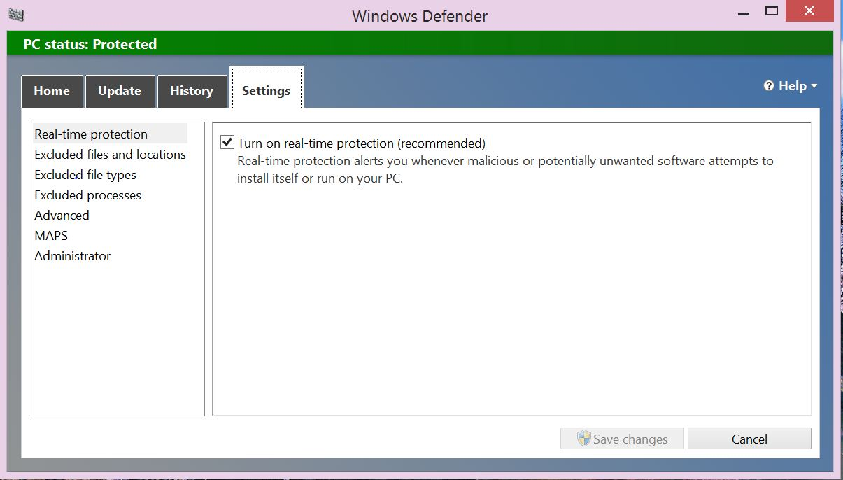

1. Next, choose **“Advanced from the menu located on the left”** and verify that “Scan archive files” and “Scan removable devices” are checked. Other options are at your discretion.

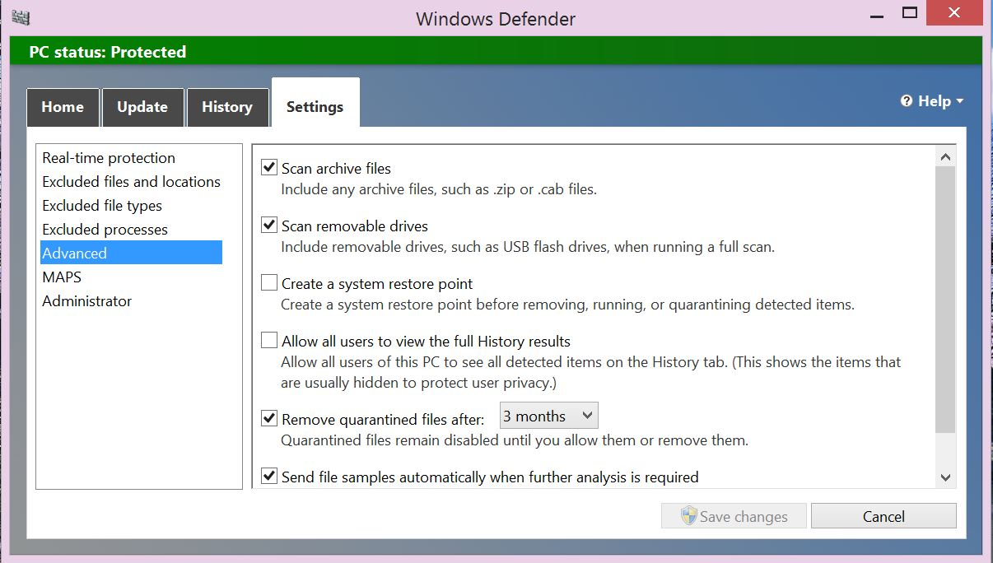

1. Once you have finished choosing your settings, click on the Update tab and click on the Update button located on the right hand side.

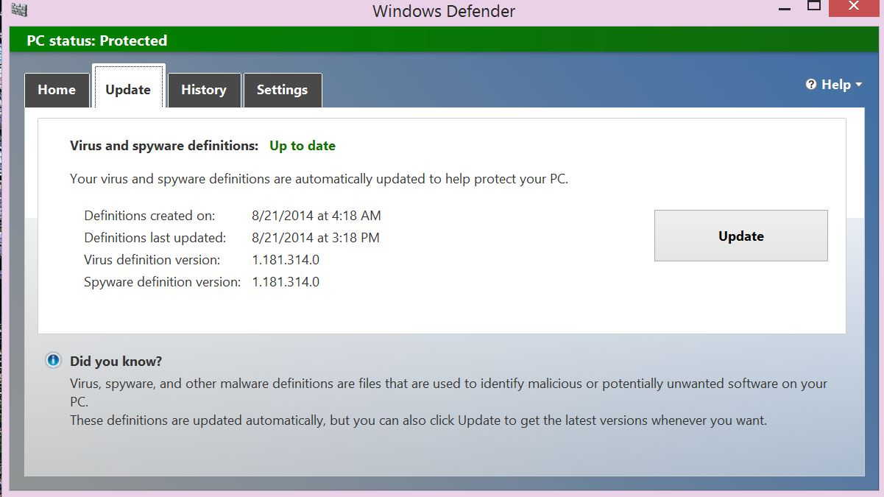

1. Once your virus definitions are updated, click on the home tab and perform a Full Scan on the hard drive.

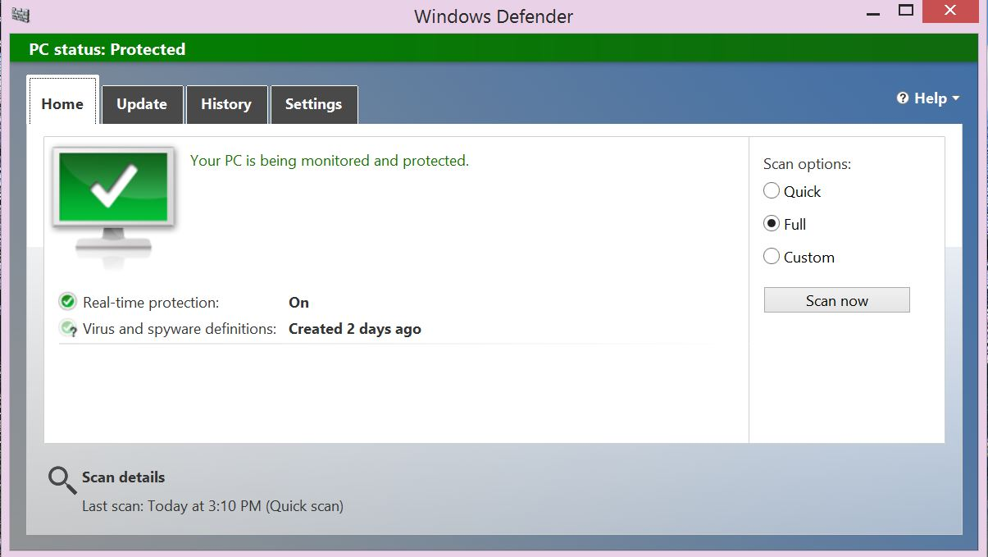

Once a Full Scan of the hard drive has been has been completed, take a screen shot of the completed scan and show it to your lab teacher. If you are completing the lab after your scheduled lab period, save the screen shot to your hard drive. You can show your completed Full Scan screen shot to your Computer Essentials lab teacher during your next scheduled Computer Essentials lab.

CST8101 Sign off sheet

## 

Lab Section number: __________________________________

Print your full name: __________________________________

## Marking Guide

|  |  |
| --- | --- |
| **1 Mark** | Ability to connect to ACSecure network by wireless |
| **2 Marks** | Printing a test page and verifying it printed ok |
| **2 Marks** | Attempted to connect to other printers in the College- test page not required |
| **2Marks** | All essential updates are installed |
| **3 Marks** | An anti-virus program is installed, hard drive scanned and is virus free |
|  | Total our of 10 marks |